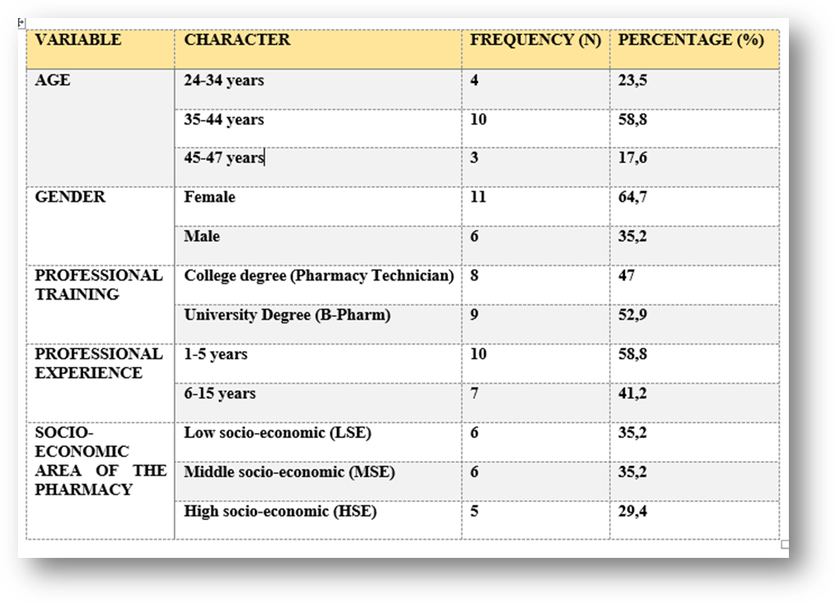Table 2. Sociodemographic characteristics - Pharmacists (n=17)

